**Accelerating Perovskite Solar Cell Performance Prediction with Machine Learning on Existing Experimental Data**

*Subham Subba, Suman Chatterjee*

Department of Physics,

University of North Bengal

rs_subhamsu@nbu.ac.in, suman@nbu.ac.in

*Supplementary File 1 (S1)*

**Fig S1:** *Correlation heatmap of all features*

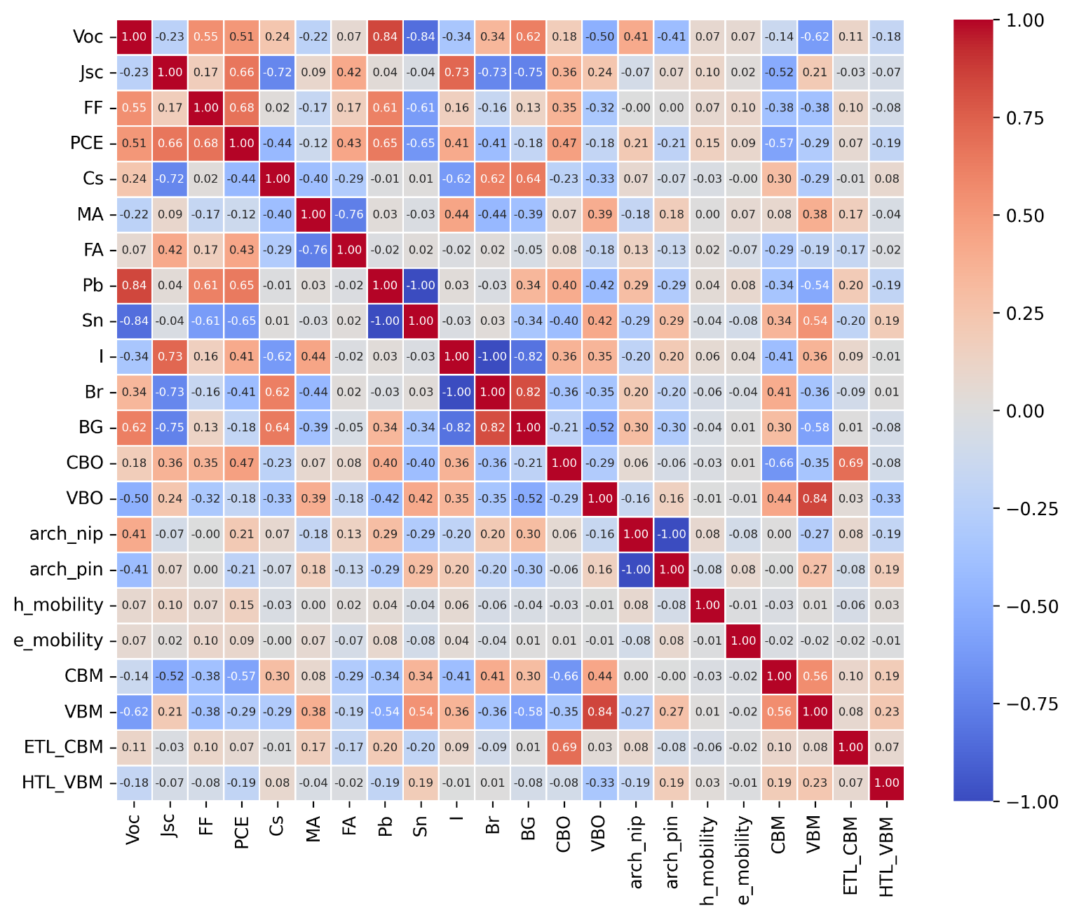

**Table S1:** *RMSE and r-values of different models for PCE prediction*

|  |  |  |  |  |  |
| --- | --- | --- | --- | --- | --- |
| **Parameter** | **Algorithm** | **Training Set** | | **Test Set** | |
| **RMSE** | **r-value** | **RMSE** | **r-value** |
| **PCE** | RFPCE | 0.635 | 0.987 | 1.191 | 0.959 |
| GBRPCE | 0.999 | 0.964 | 1.159 | 0.961 |
| XGBPCE | 0.138 | 0.999 | 1.169 | 0.957 |
| **CBPCE** | **0.497** | **0.991** | **1.095** | **0.964** |
| **Voc** | **RFVoc** | **0.022** | **0.990** | **0.033** | **0.979** |
| GBRVoc | 0.033 | 0.978 | 0.034 | 0.983 |
| XGBVoc | 0.009 | 0.998 | 0.036 | 0.975 |
| CBVoc | 0.079 | 0.992 | 0.037 | 0.979 |
| **Jsc** | **RFJsc** | **0.543** | **0.988** | **1.013** | **0.958** |
| GBRJsc | 0.744 | 0.977 | 1.171 | 0.942 |
| XGBJsc | 0.238 | 0.998 | 1.210 | 0.938 |
| CBJsc | 0.419 | 0.993 | 1.126 | 0.946 |
| **FF** | **RFFF** | **0.016** | **0.978** | **0.031** | **0.614** |
| GBRFF | 0.026 | 0.927 | 0.035 | 0.491 |
| XGBFF | 0.003 | 0.999 | 0.037 | 0.524 |
| CBFF | 0.014 | 0.980 | 0.035 | 0.570 |

**Fig S2:** *Fitting Performance of different models for PCE prediction*

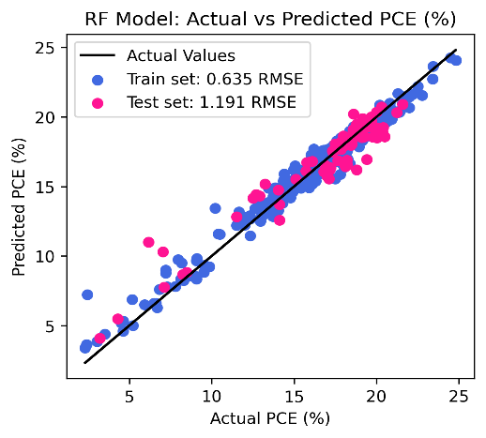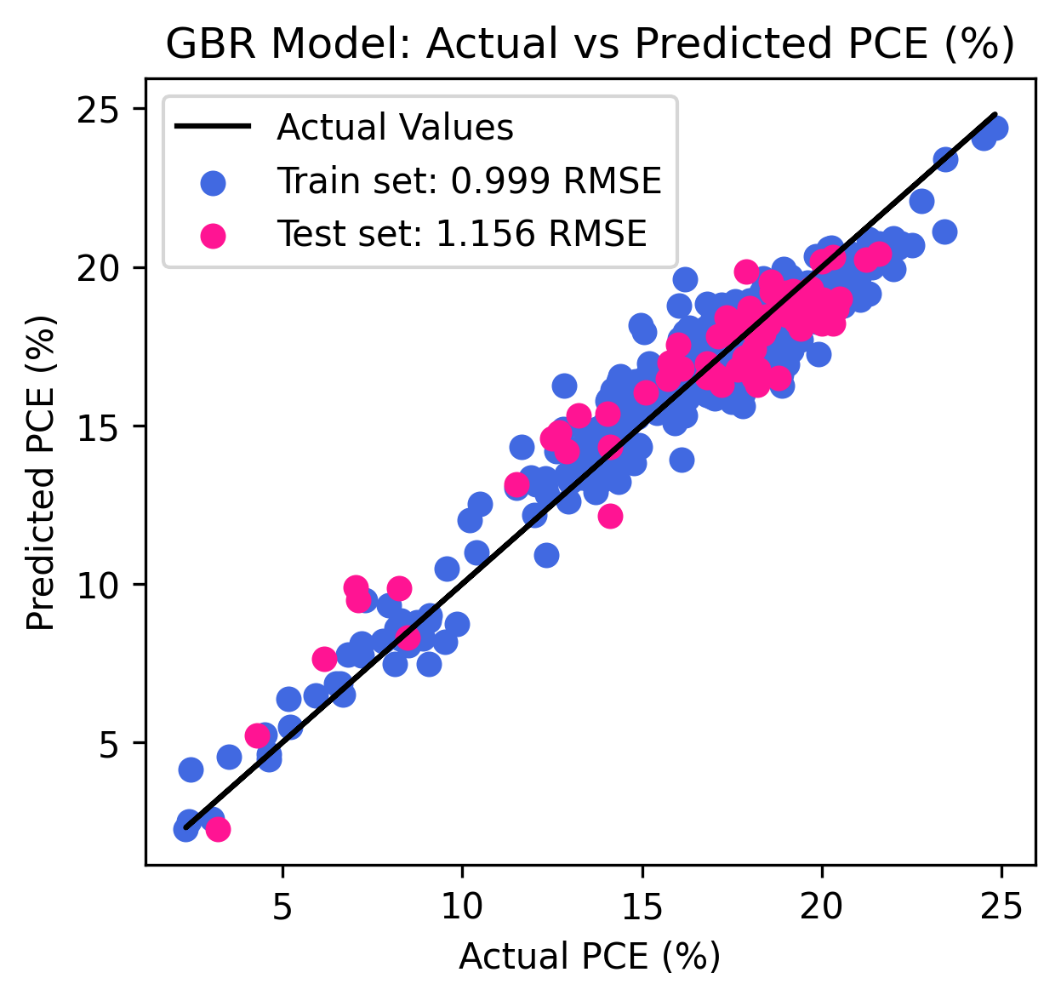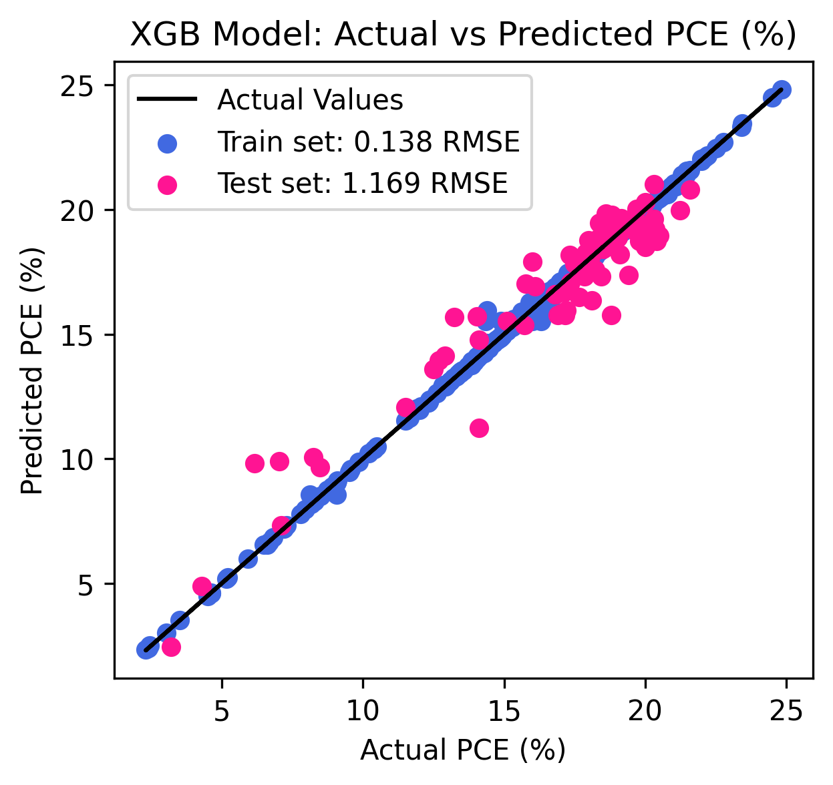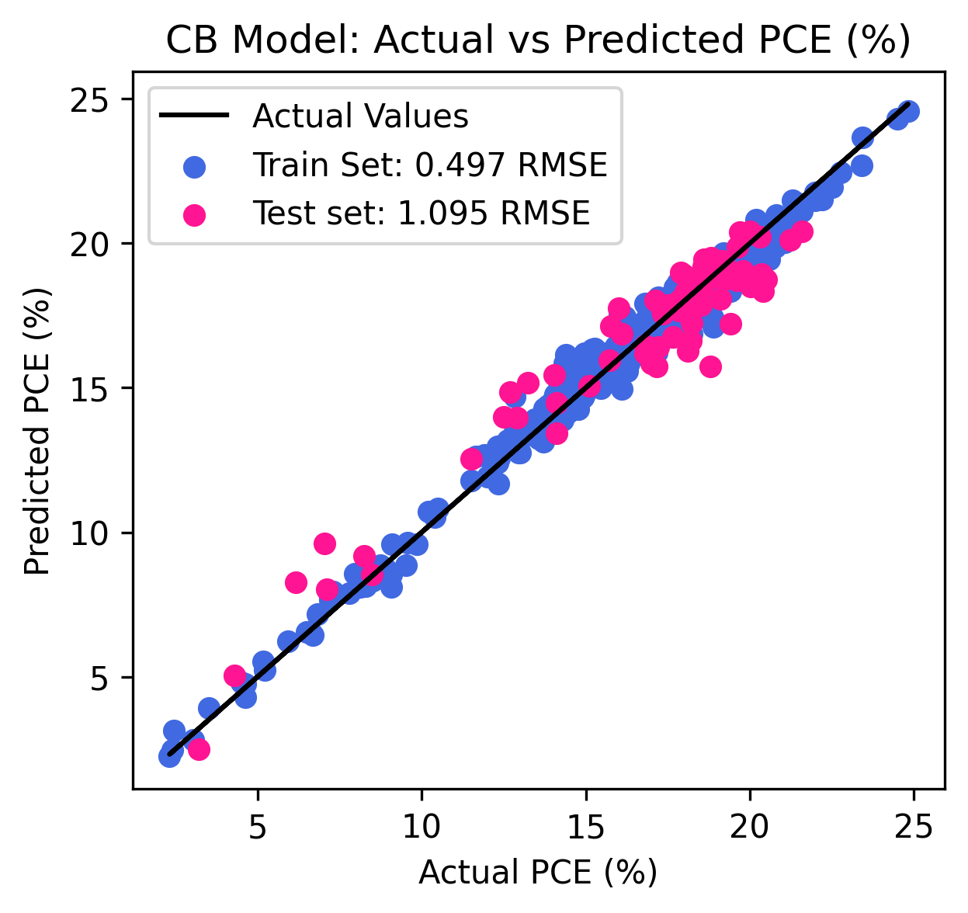

**Fig S3:** *Fitting Performance of different models for Voc prediction*

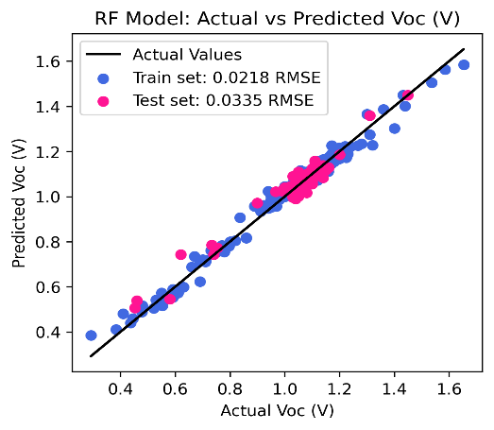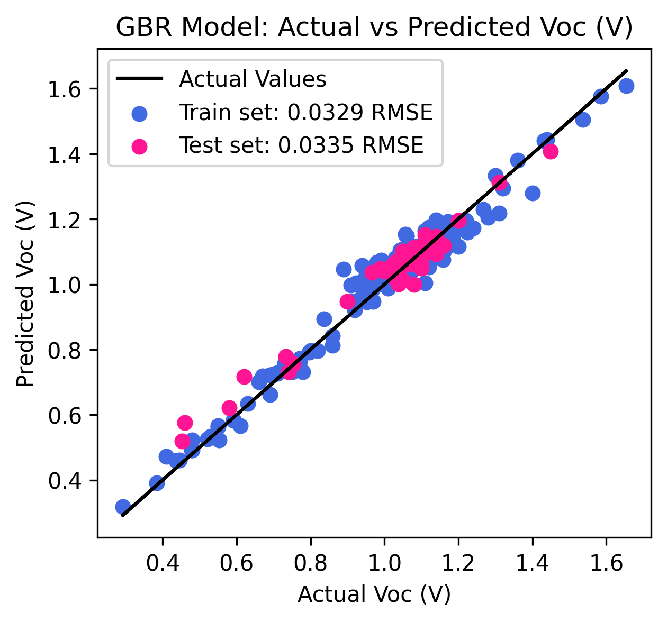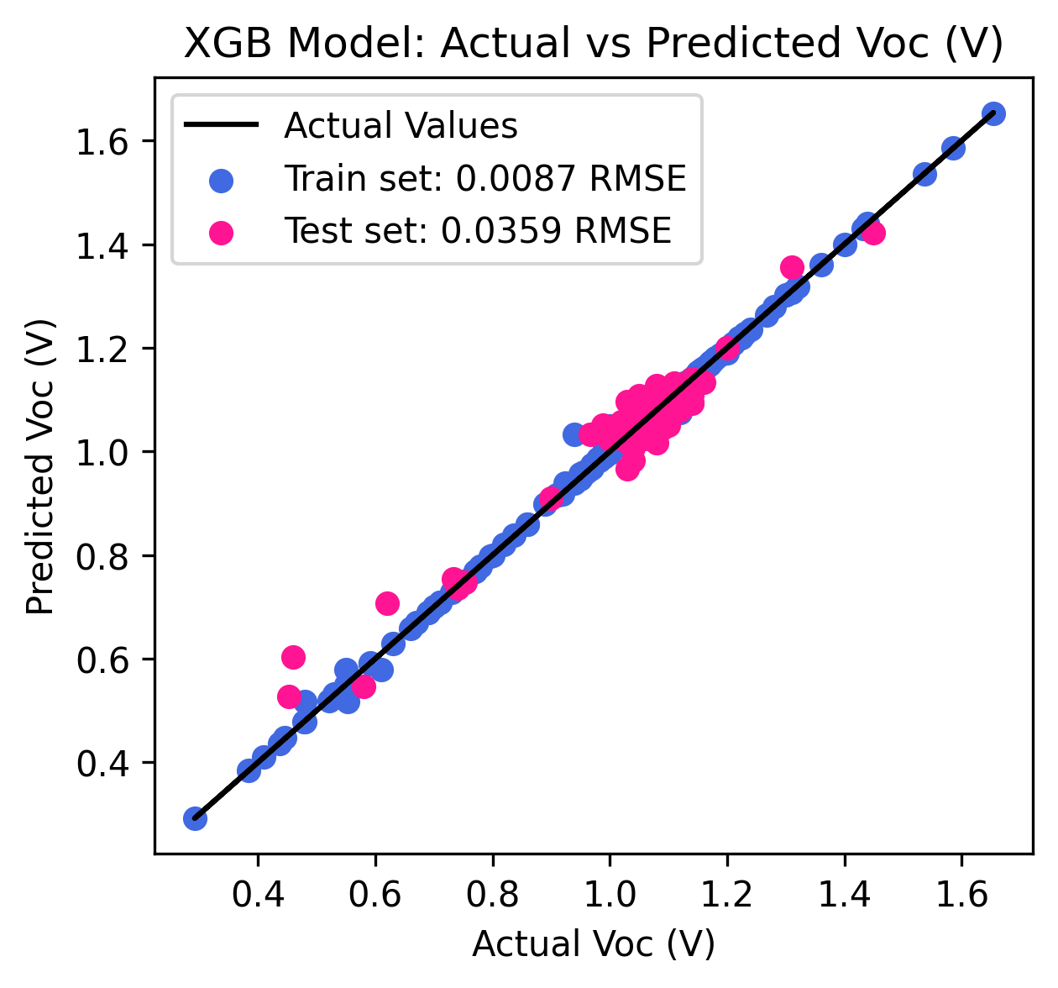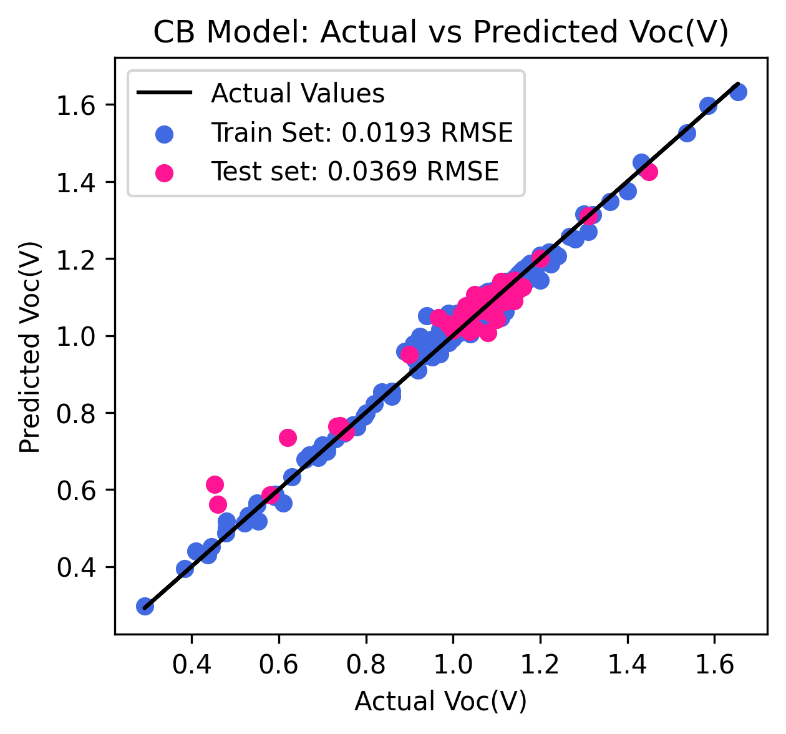

**Fig S4:** *Fitting Performance of different models for Jsc prediction*

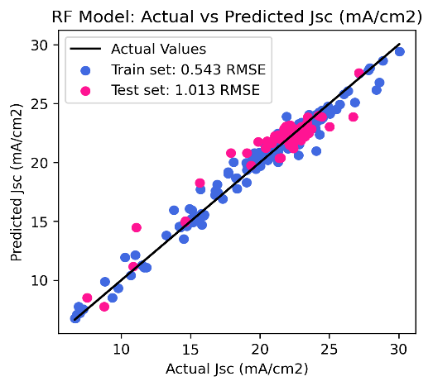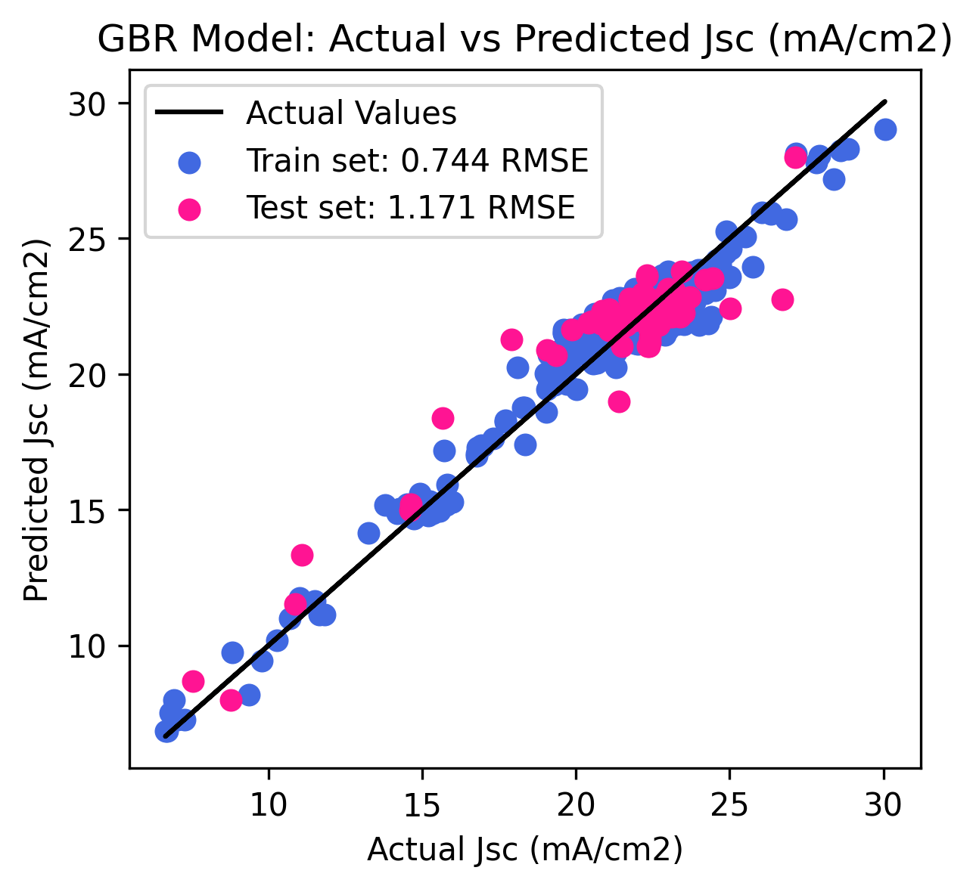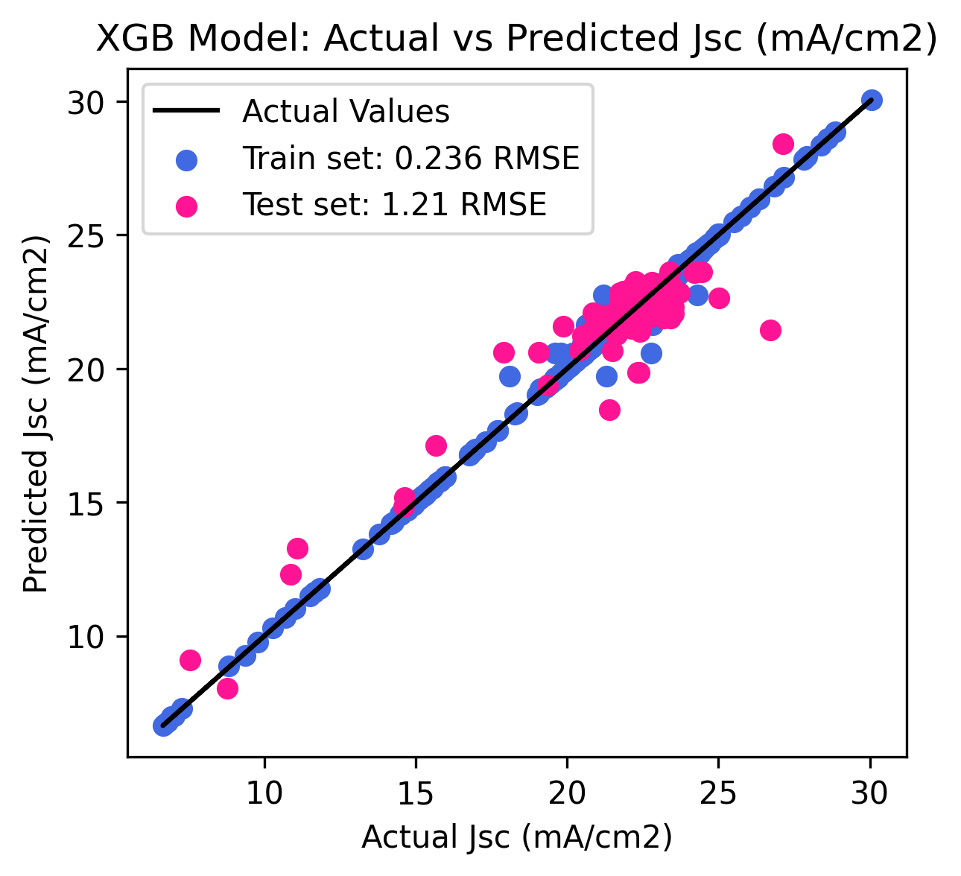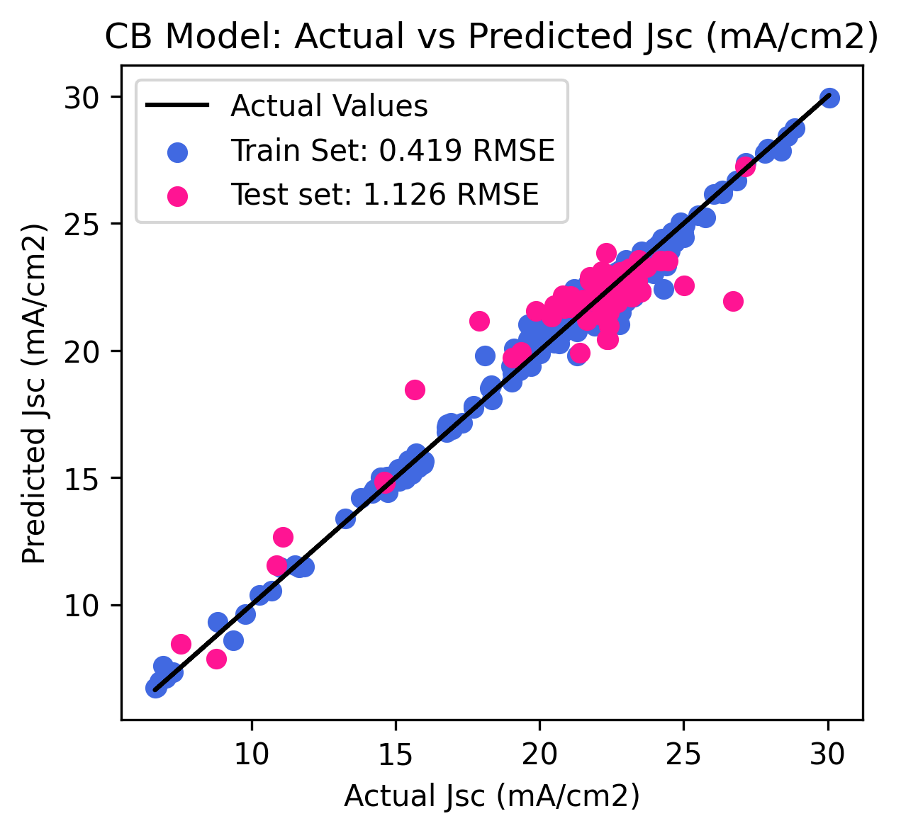

**Fig S5:** *Fitting Performance of different models for FF prediction*

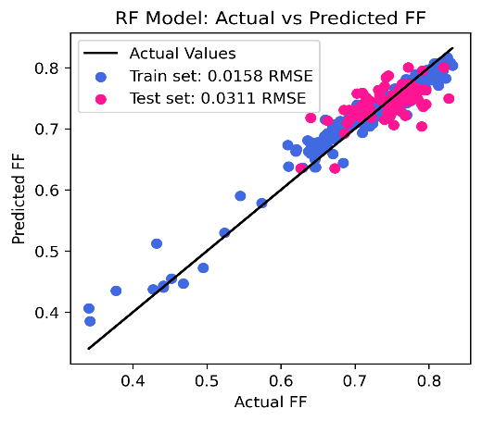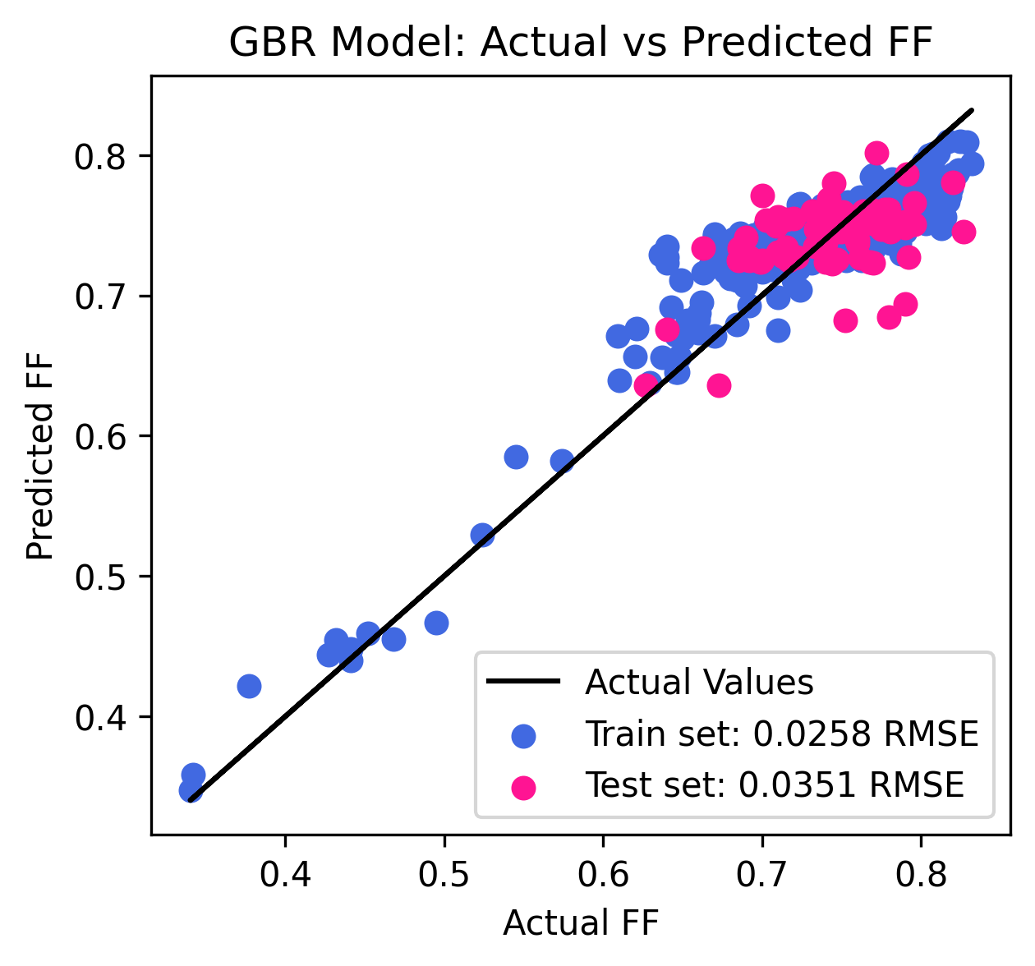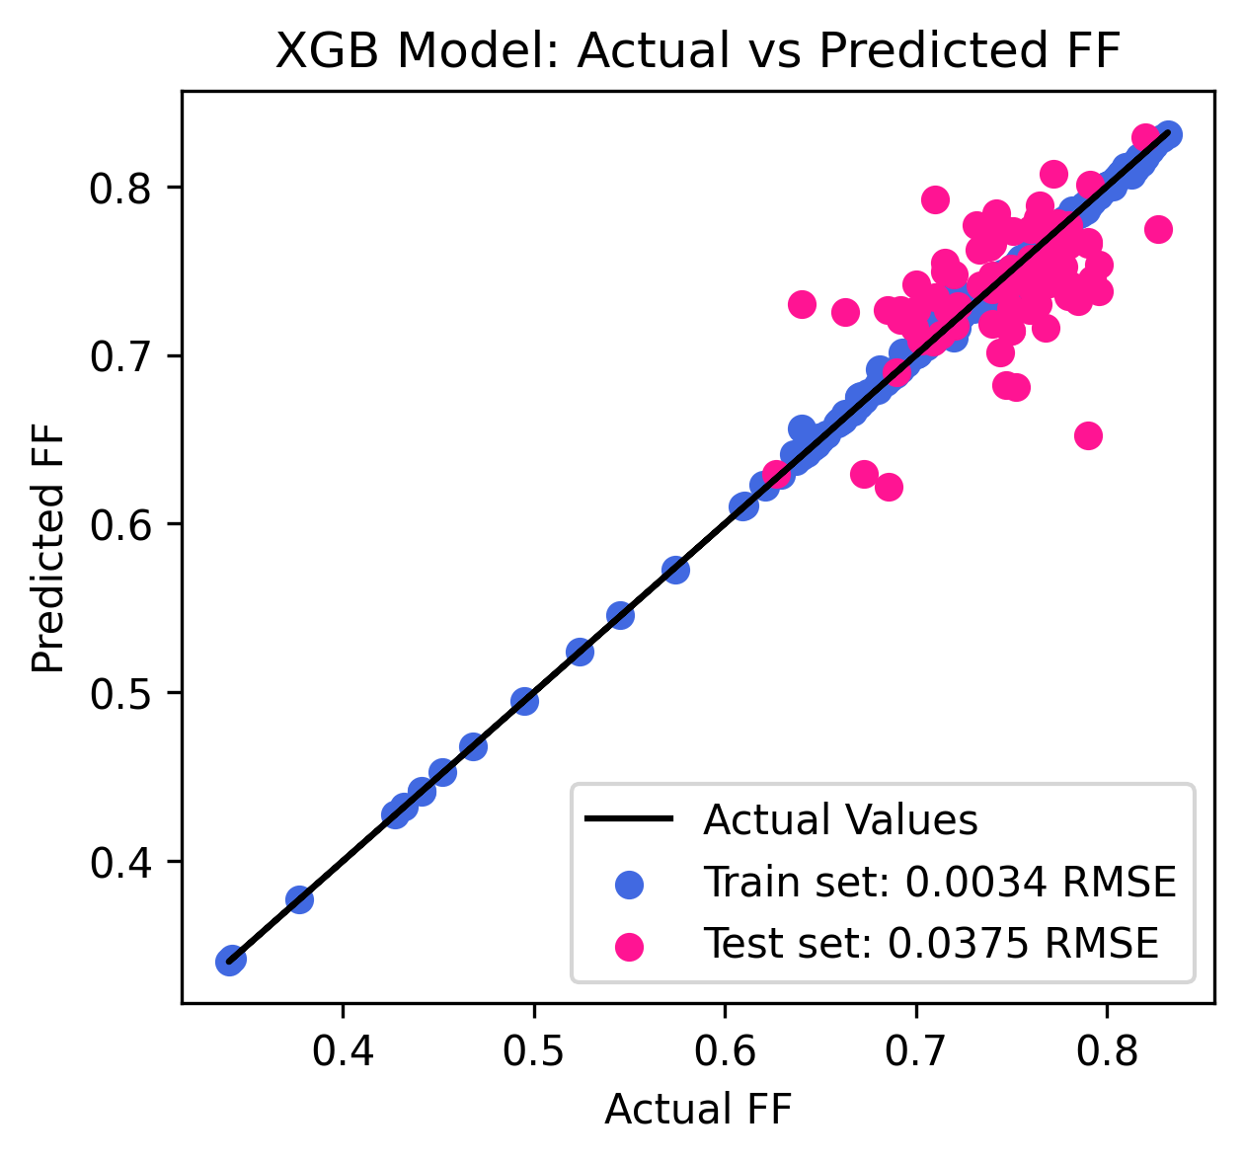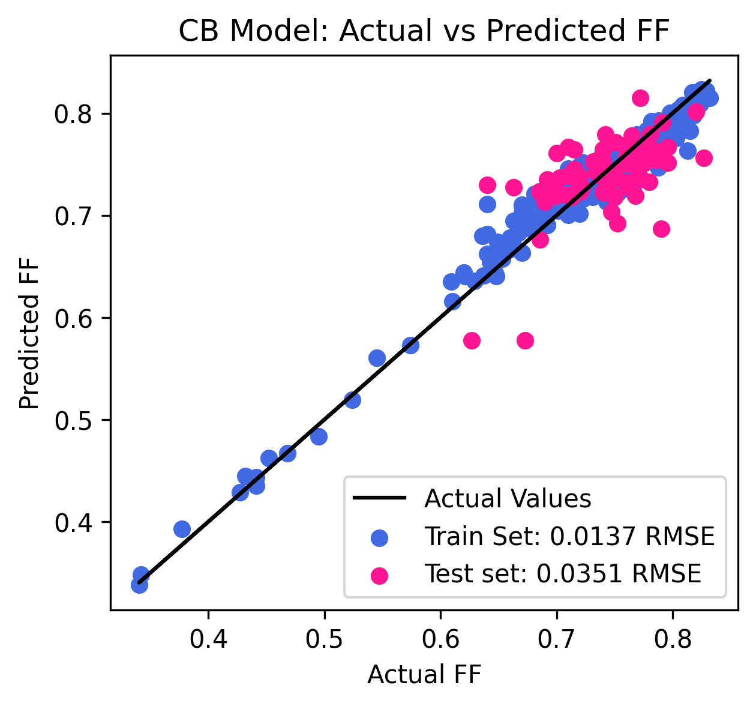

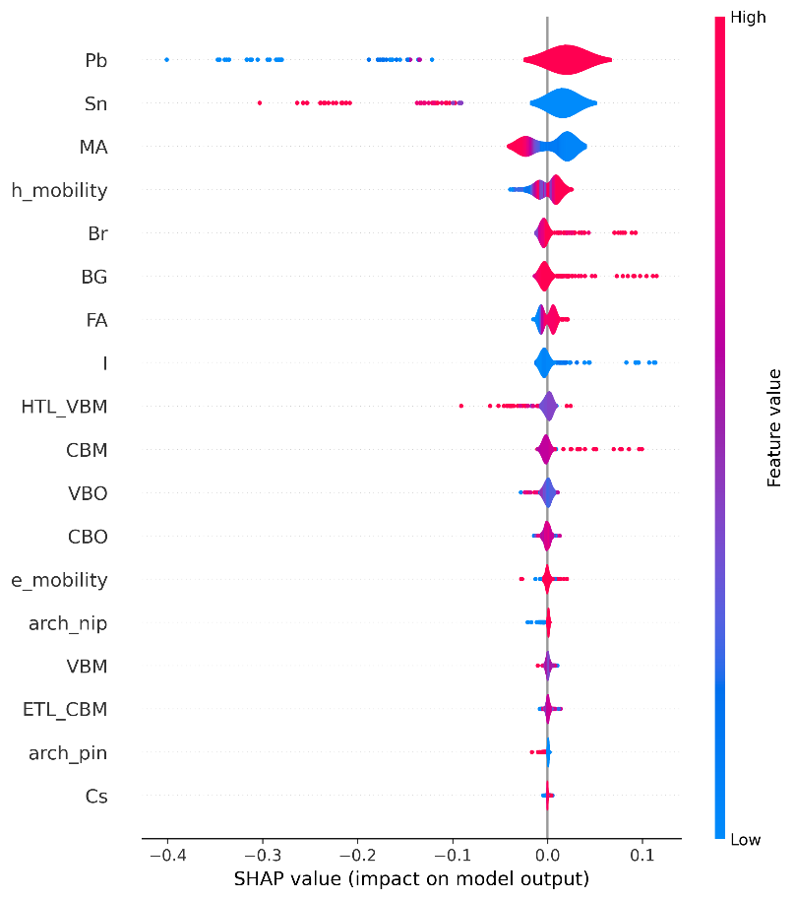**Fig S6:** *SHAP Beeswarm plot of (a) CBPCE, (b) RFVoc, (c) RFJsc, and (d) RFFF,*

**(b)**

**(a)**

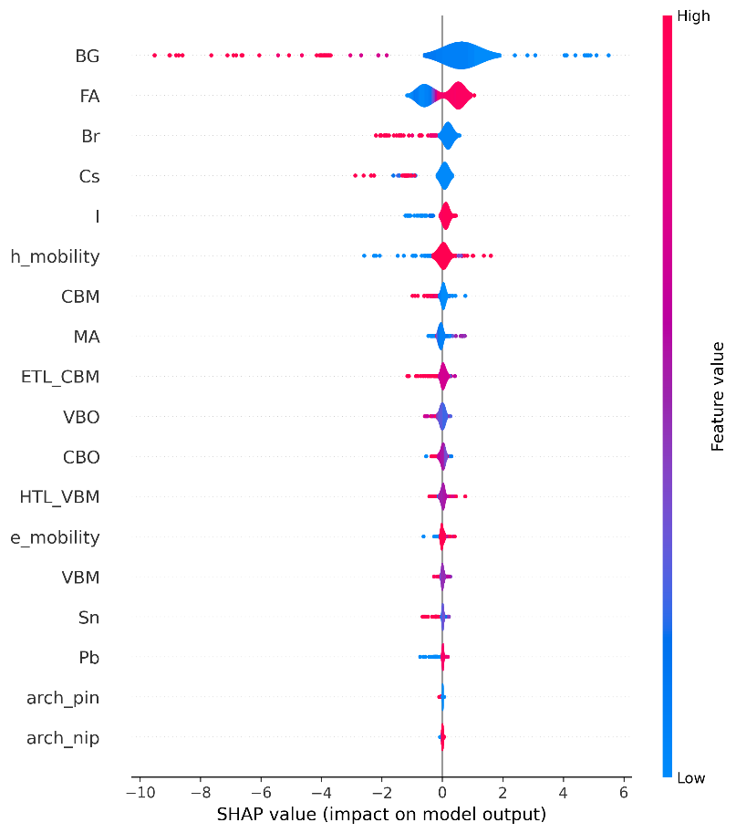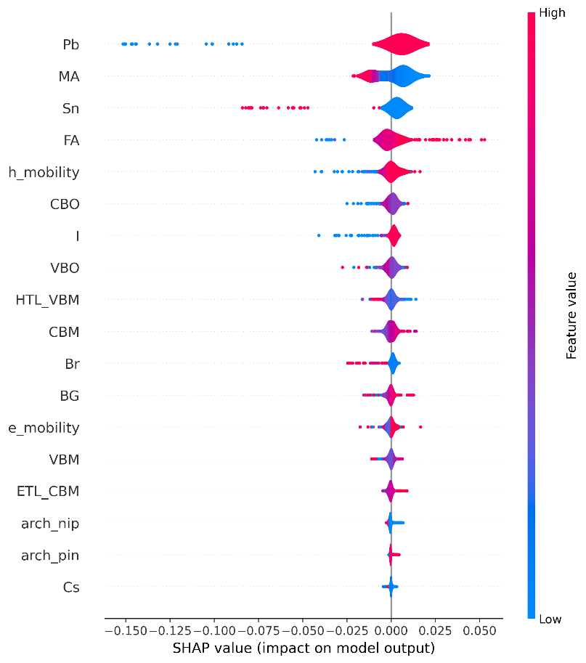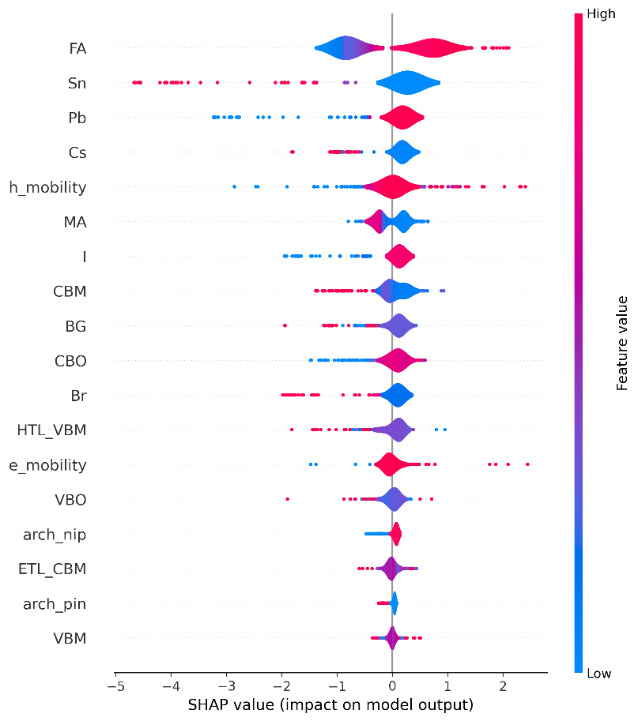

**(d)**

**(c)**

**Fig S7:** *Feature dependence (FD) plot for RFVoc : (a) BG, and (b) FA.*

*FD plot for RFJsc of (c) BG.*

*FD plot for RFFF of (d) BG, and (e) FA.*

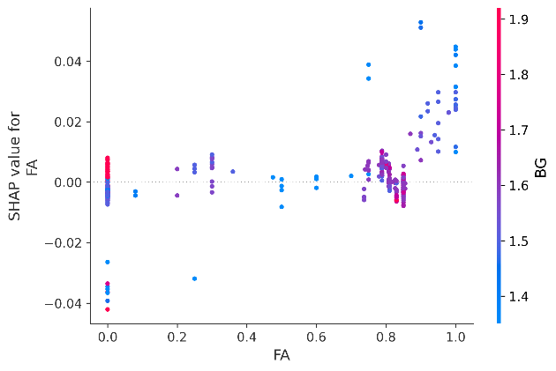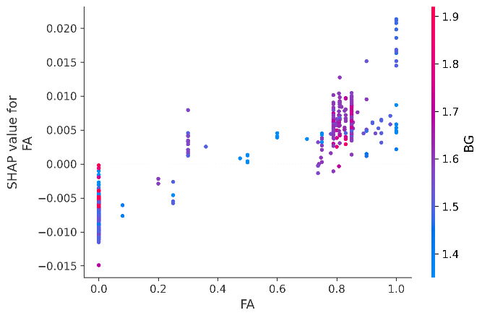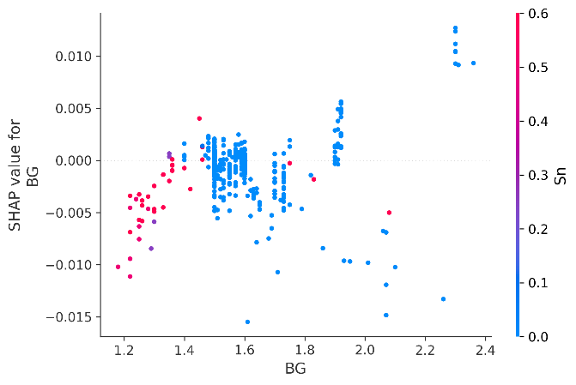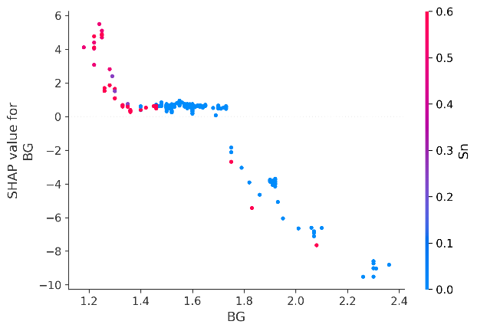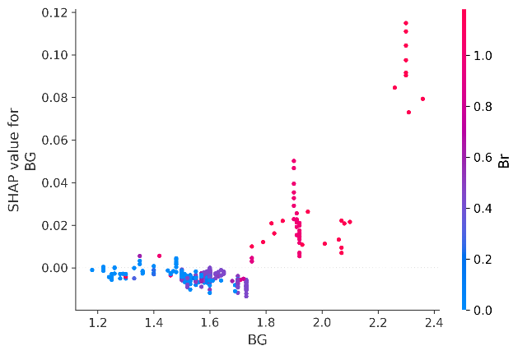

**(e)**

**(d)**

**(c)**

**(a)**

**(b)**

|  |  |  |  |  |  |  |  |  |  |  |  |  |  |  |  |  |  |  |
| --- | --- | --- | --- | --- | --- | --- | --- | --- | --- | --- | --- | --- | --- | --- | --- | --- | --- | --- |
| **Cs** | **MA** | **FA** | **Pb** | **Sn** | **I** | **Br** | **BG** | **CBO** | **VBO** | **arch_nip** | **arch_pin** | **h_mobility** | **e_mobility** | **CBM** | **VBM** | **ETL_CBM** | **HTL_VBM** | **Ref.** |
| 0.05 | 0.14 | 0.81 | 1 | 0 | 2.55 | 0.45 | 1.62 | 0.02 | -0.83 | 1 | 0 | 4.65E-04 | 2.93E-05 | -4.43 | -6.05 | -4.41 | -5.22 | [1] |
| 0.05 | 0.1425 | 0.8075 | 1 | 0 | 2.55 | 0.45 | 1.6 | 0 | -0.4 | 0 | 1 | 1.20E-03 | 3.50E-04 | -3.9 | -5.5 | -3.9 | -5.1 | [2] |
| 0.17 | 0 | 0.83 | 1 | 0 | 2.4 | 0.6 | 1.6 | -0.2 | -0.04 | 0 | 1 | 3.51E-04 | 8.00E-05 | -3.8 | -5.4 | -4 | -5.36 | [3] |
| 0 | 1 | 0 | 1 | 0 | 3 | 0 | 1.5 | -0.1 | -0.5 | 0 | 1 | 3.30E-04 | 4.00E-04 | -3.9 | -5.4 | -4 | -4.9 | [4] |
| 0 | 1 | 0 | 1 | 0 | 3 | 0 | 1.5 | -0.02 | -0.25 | 1 | 0 | 4.65E-04 | 5.27E-05 | -3.9 | -5.4 | -3.92 | -5.15 | [5] |
| 0.05 | 0.12 | 0.83 | 1 | 0 | 2.55 | 0.45 | 1.61 | -0.14 | -0.48 | 1 | 0 | 4.65E-04 | 2.93E-05 | -4.07 | -5.68 | -4.21 | -5.2 | [6] |
| 0 | 1 | 0 | 1 | 0 | 3 | 0 | 1.6 | -0.1 | -0.3 | 0 | 1 | 3.30E-04 | 3.34E-04 | -3.8 | -5.4 | -3.9 | -5.1 | [7] |
| 1 | 0 | 0 | 1 | 0 | 1 | 2 | 2.05 | -0.5 | -0.33 | 1 | 0 | 4.65E-04 | 2.93E-05 | -3.5 | -5.55 | -4 | -5.22 | [8] |
| 0 | 0.8 | 0.2 | 1 | 0 | 2.88 | 0.12 | 1.6 | -0.18 | -0.33 | 1 | 0 | 4.65E-04 | 2.93E-05 | -3.93 | -5.53 | -4.11 | -5.2 | [9] |
| 0 | 1 | 0 | 1 | 0 | 3 | 0 | 1.51 | -0.07 | -0.06 | 0 | 1 | 5.10E-05 | 4.00E-04 | -3.93 | -5.44 | -4 | -5.38 | [10] |
| 0 | 1 | 0 | 1 | 0 | 3 | 0 | 1.51 | -0.07 | -0.07 | 0 | 1 | 2.10E-05 | 4.00E-04 | -3.93 | -5.44 | -4 | -5.37 | [10] |
| 0.05 | 0.14 | 0.81 | 1 | 0 | 2.55 | 0.45 | 1.6 | -0.1 | -0.29 | 1 | 0 | 4.60E-04 | 2.93E-05 | -4.2 | -5.8 | -4.3 | -5.51 | [11] |

**Table S2:** *Input values for the 12 validation samples*

***References:***

1. Zhao, Y., Han, Z., Zhou, W., Li, Q., Fu, R., Yu, D., & Zhao, Q. (2019). Water‐Based TiO2 Nanocrystal as an Electronic Transport Layer for Operationally Stable Perovskite Solar Cells. *Solar RRL*, *3*(9), 1900167.
2. Shi, Y., Chen, W., Wu, Z., Wang, Y., Sun, W., Yang, K., ... & Guo, X. (2020). Imide-functionalized acceptor–acceptor copolymers as efficient electron transport layers for high-performance perovskite solar cells. *Journal of Materials Chemistry A*, *8*(27), 13754-13762.
3. Yan, M., Xiang, T., Yu, X., Xiao, J., Li, W., Ku, Z., ... & Cheng, Y. B. (2020). Room-temperature Sputtered NiOx for hysteresis-free and stable inverted Cs-FA mixed-cation perovskite solar cells. *Materials Science in Semiconductor Processing*, *115*, 105129.
4. Wang, B., Zeng, Q., Sun, Z., Xue, S., & Liang, M. (2019). Molecularly engineering of truxene-based dopant-free hole-transporting materials for efficient inverted planar perovskite solar cells. *Dyes and Pigments*, *165*, 81-89.
5. Wu, M. C., Chan, S. H., Lee, K. M., Chen, S. H., Jao, M. H., Chen, Y. F., & Su, W. F. (2018). Enhancing the efficiency of perovskite solar cells using mesoscopic zinc-doped TiO 2 as the electron extraction layer through band alignment. *Journal of Materials Chemistry A*, *6*(35), 16920-16931.
6. Zhang, M., Zhou, W., Hu, W., Li, B., Qiao, Q., & Yang, S. (2020). Modifying mesoporous TiO2 by ammonium sulfonate boosts performance of perovskite solar cells. *ACS Applied Materials & Interfaces*, *12*(11), 12696-12705.
7. Castro, E., Fernandez-Delgado, O., Arslan, F., Zavala, G., Yang, T., Seetharaman, S., ... & Echegoyen, L. (2018). New thiophene-based C 60 fullerene derivatives as efficient electron transporting materials for perovskite solar cells. *New Journal of Chemistry*, *42*(17), 14551-14558.
8. Liu, P., Yang, X., Chen, Y., Xiang, H., Wang, W., Ran, R., ... & Shao, Z. (2020). Promoting the efficiency and stability of CsPbIBr2-based all-inorganic perovskite solar cells through a functional Cu2+ doping strategy. *ACS Applied Materials & Interfaces*, *12*(21), 23984-23994.
9. Liu, C., Su, H., Wei, C., Xie, K., Wang, H., Zhai, P., ... & Liu, L. (2020). Tunable electronic properties of TiO2 nanocrystals by in situ dopamine functionalization for planar perovskite solar cells. *Electrochimica Acta*, *354*, 136720.
10. Pham, H. D., Hu, H., Feron, K., Manzhos, S., Wang, H., Lam, Y. M., & Sonar, P. (2017). Thienylvinylenethienyl and naphthalene core substituted with triphenylamines—Highly efficient hole transporting materials and their comparative study for inverted perovskite solar cells. *Solar RRL*, *1*(8), 1700105.
11. Qiu, L., Zheng, X., Yang, Y., Dong, Y., Dong, G., Xia, D., ... & Fan, R. (2019). A copper coordination polymer with matching energy level for modifying hole transport layers to improve the performance of perovskite solar cells. *ChemSusChem*, *12*(12), 2763-2772.